*PROJECT 5TH* *ΚΑΡΑΒΙΑ ΜΑΡΙΑ ΣΠΥΡΙΔΟΥΛΑ (2026202100049)*   
*FSM ELEVATOR* *ΣΑΜΑΚΟΒΛΗ ΕΥΦΡΟΣΥΝΗ (2026202100142)*

library IEEE;

use IEEE.STD_LOGIC_1164.ALL;

--Ορισμός Εισόδων και Εξόδων

entity Elevetor_C is

Port ( clk : in STD_LOGIC;

rst : in STD_LOGIC;

r_up : in STD_LOGIC_VECTOR(9 downto 0);

r_down : in STD_LOGIC_VECTOR(9 downto 0);

floor_s : in STD_LOGIC_VECTOR(9 downto 0);

motor_c : out STD_LOGIC_VECTOR (3 downto 0);

door_c : out STD_LOGIC;

current_floor : out STD_LOGIC_VECTOR(3 downto 0));

end Elevetor_C;

--Aρχιτεκτονικη Συμπεριφορας

architecture Behavioral of Elevetor_C is

type Elevator_C is (Idle, MovingUp, MovingDown, OpenDoor, CloseDoor, Waiting,OpeningDoor,ClosingDoor);

--Δηλωσεις ενδιαμεσων σηματων

signal current_state: Elevetor_C;

signal next_state : Elevator_C;

signal door_state : Idle ;

signal next_door_state : Elevator_C;

signal r_floors : STD_LOGIC_VECTOR(9 downto 0);

signal t_floor : integer range 0 to 9;

begin

--Εναρξης Διεργασιας

process (clk, rst)

begin

if rst = '1' then

current_state <= Idle;

r_floors <= (others => '0');

t_floor <= 0;

elsif rising_edge(clk) then

current_state <= next_state;

end if;

end process;

process (current_state, r_up, r_down, floor_s)

begin

--Περιπτωσεις Καταστασης Ανελκυστηρα(Λογικη Συμπεριφορα)

case current_state is

when Idle =>

if r_up /= (others => '0') or r_down /= (others => '0') then

t_floor <= t_floor;

next_state <= MovingUp;

else

next_state <= Idle;

end if;

when MovingUp =>

if floor_s = "t_floor" then

next_state<=OpenDoor;

elsif r_up /= (others => '0') then

next_state<= MovingUp;

else

next_state<=Waiting;

current_state <= MovingUp;

end if;

when MovingDown=>

if floor_s = "t_floor" then

next_state<=OpenDoor;

elsif r_down /= (others => '0') then

current_state<=MovingDown;

next_state<= OpenDoor;

else

next_state<=Waiting;

end if;

end case;

end process;

process (door_state,next_door_state,current_state,OpenDoor, CloseDoor,Waiting,OpeningDoor,ClosingDoor)

begin

--Καταστασεις Πορτας

case door_state is

when OpeningDoor =>

if door_state = OpenDoor then

next_door_state <= OpenDoor;

elsif door_state = ClosingDoor then

next_door_state <= ClosingDoor;

else

next_door_state <= Waiting;

end if;

when ClosingDoor =>

if door_state = CloseDoor then

next_door_state <= CloseDoor;

elsif door_state = OpeningDoor then

next_door_state <= OpeningDoor;

else

next_door_state <= Waiting;

end if;

when others =>

next_door_state <= Waiting;

end case;

end process;

--Ελέγχου Κινητήρα

motor_c <= "01" when current_state = MovingUp else

"10" when current_state = MovingDown else

"00" when current_state = Idle ;

--Ελέγχου Θυρών

door_c <= '1' when current_state = OpenDoor else '0';

motor_c <= motor_c ;

door_c <= door_c;

current_floor <= (others => '0');

end Behavioral;

*--TEST BENCH*

library IEEE;

use IEEE.STD_LOGIC_1164.ALL;

--ΔΗΛΛΩΣΗ ΟΝΤΟΤΗΤΑΣ

entity Elevetor_c_tb is

end Elevetor_c_tb;

--ΑΡΧΙΤΕΚΤΟΝΙΚΗ ΣΥΜΠΕΕΡΙΦΟΡΑΣ

architecture Behavioral of Elevetor_c_tb is

--ΕΝΔΙΑΜΕΣΑ ΛΟΓΙΚΑ ΣΗΜΑΤΑ

signal clk, rst : STD_LOGIC := '0';

signal r_up, r_down, floor_s : STD_LOGIC_VECTOR(9 downto 0) := (others => '0');

signal motor_c, door_c : STD_LOGIC;

signal current_floor : STD_LOGIC_VECTOR(3 downto 0);

--ΚΑΘΟΡΙΣΜΟΣ ΘΥΡΩΝ

component Elevator_C

Port (

clk : in STD_LOGIC;

rst : in STD_LOGIC;

r_up : in STD_LOGIC_VECTOR(9 downto 0);

r_down : in STD_LOGIC_VECTOR(9 downto 0);

floor_s : in STD_LOGIC_VECTOR(9 downto 0);

motor_c : out STD_LOGIC;

door_c : out STD_LOGIC;

current_floor : out STD_LOGIC_VECTOR(3 downto 0)

);

end component;

--ΧΑΡΤΗΣ ΘΥΡΩΝ

begin

UUT: Elevator_C

port map (

clk => clk,

rst => rst,

r_up => r_up,

r_down => r_down,

floor_s => floor_s,

motor_c => motor_c,

door_c => door_c,

current_floor => current_floor

);

--ΔΙΕΡΓΑΣΙΑ ΠΑΡΑΓΩΓΗΣ ΠΡΟΣΟΜΕΙΩΜΕΝΟΥ ΣΗΜΑΤΟΣ ΡΟΛΟΓΙΟΥ

CLK_GEN: process

begin

while now < 1000 ns loop

clk <= '0';

wait for 5 ns;

clk <= '1';

wait for 5 ns;

end loop;

wait;

end process;

--ΔΙΕΡΓΑΣΙΑ ΓΙΑ ΤΗΝ ΔΟΚΙΜΗ ΤΟΥ ΑΝΕΛΚΥΣΤΗΡΑ

STIMULUS: process

begin

rst <= '1';

wait for 10 ns;

rst <= '0';

wait for 10 ns;

r_up <= "0000000001";

wait for 100 ns;

r_up <= (others => '0');

wait for 10 ns;

r_down <= "0000000001";

wait for 100 ns;

r_down <= (others => '0');

wait for 10 ns;

wait;

end process;

end Behavioral;

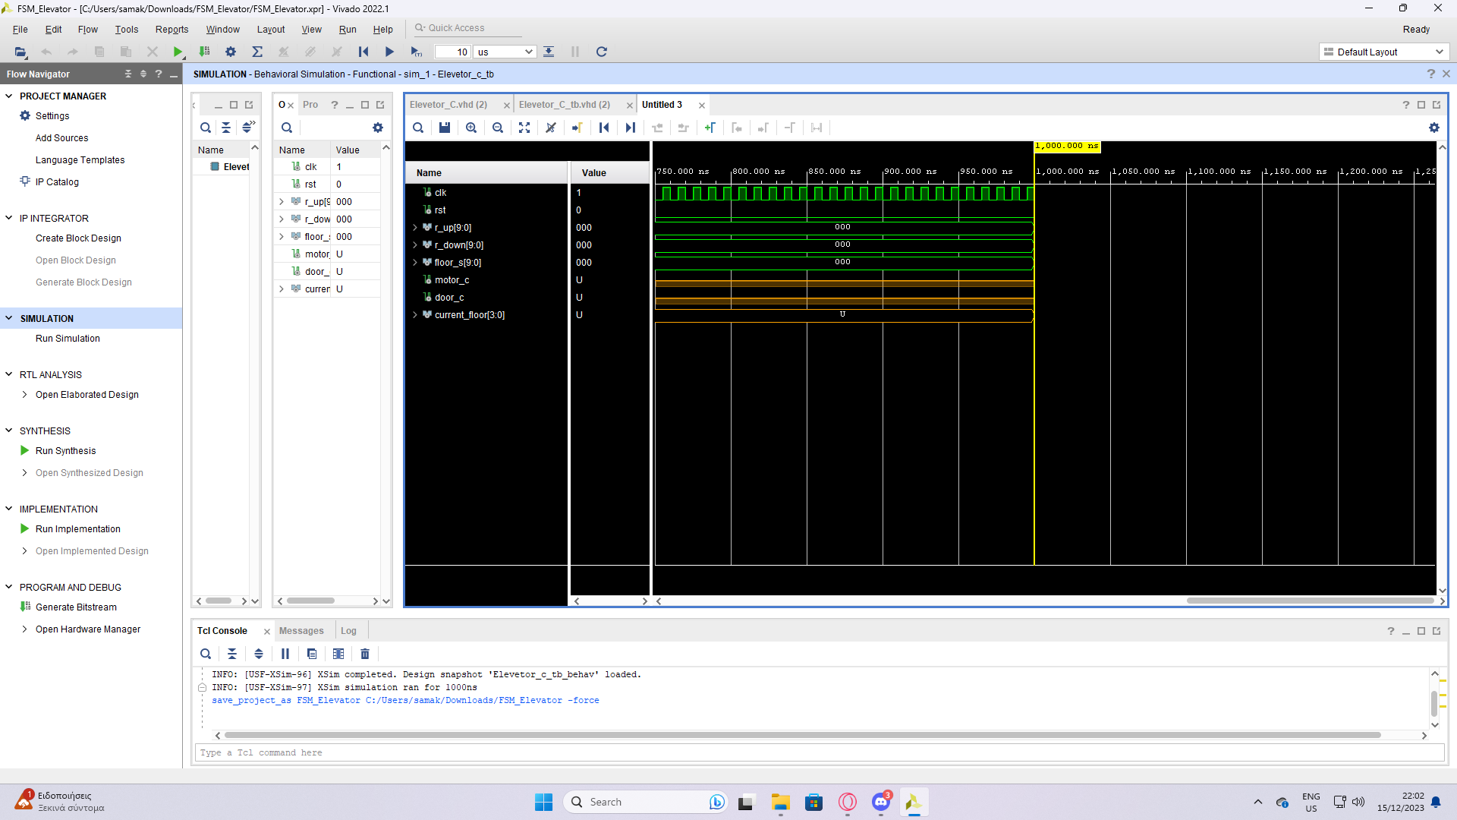

ΑΝΑΛΥΣΗ ΤΗΣ ΣΧΕΔΙΑΣΗΣ

1. Δηλώνουμε τις εισόδους και τις εξόδους της οντότητας
2. Στην αρχιτεκτονική συμπεριφοράς:
3. Δημιουργούμε μια διεργασία για το ρολόι.
4. Δημιουργούμε μια διεργασία την λογική συμπεριφορά του ανελκυστήρα ,δηλαδή πως συμπεριφέρεται εάν βρίσκεται σε αδρανή κατάσταση, όταν ανεβαίνει ή όταν κατεβαίνει.
5. Δημιουργούμε μια διεργασία για τις καταστάσεις της πόρτας
6. Για τον έλεγχο του κινητήρα, δίνουμε τιμές όπου η κάθε μια αντιστοιχεί σε διαφορετική κατάσταση του κινητήρα.
7. Τέλος, κάνουμε τον έλεγχο των θυρών.

